**Lab 7**

* Problem 1:

Source code:

#include <stdio.h>

int main()

{

int n,sum=0,i;

printf("Enter the size of array: ");

scanf("%d",&n);

int a[n];

printf("Enter %d array elements:\n ",n);

for (i=0;i<n;i++)

{

scanf("%d",&a[i]);

}

for (i=0;i<n; i++)

{

sum=sum+a[i];

}

printf("Sum is: %d",sum);

}

Output:

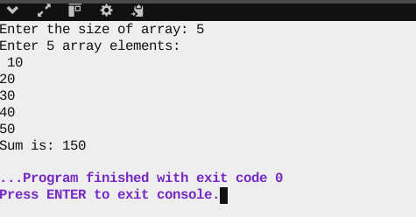

* Problem 2:

Source code:

#include <stdio.h>

int main()

{

int a[10]={1,2,3,4,5,6,7,8,9},i,n,found=0;

printf("Enter the element to find(1-9): ");

scanf("%d",&n);

for (i=0;i<9;i++)

{

if(a[i]==n)

{

printf("%d is at index: %d",n,i);

found=1;

break;

}

}

if(found==0)

printf("Element not found in array");

}

Output:

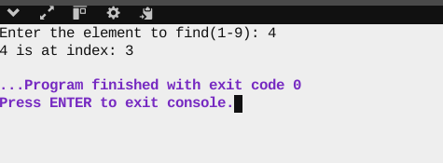

* Problem 3:

Source code:

#include <stdio.h>

int main()

{

int n,sum=0,i;

printf("Enter the size of array: ");

scanf("%d",&n);

int a[n];

printf("Enter %d array elements:\n ",n);

for (i=0;i<n;i++)

{

scanf("%d",&a[i]);

}

printf("Reverse order: ");

for (i=n-1;i>=0; i--)

{

printf("\n%d",a[i]);

}

}

Output:

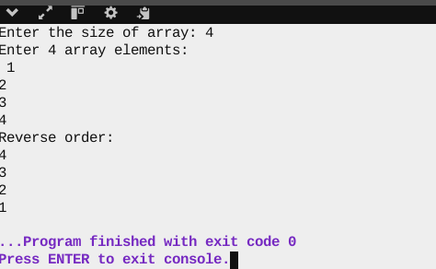

* Problem 4:

Source code:

#include <stdio.h>

int main()

{

char name[100], email[100], phone[100];

int i, valid1 = 0, valid2 = 0, at_count = 0, dot_count = 0;

printf("Enter your name: ");

scanf(" %[^\n]", name);

printf("Enter your email: ");

scanf(" %[^\n]", email);

printf("Enter your phone number: ");

scanf(" %[^\n]", phone);

// Email validation

for (i = 0; email[i] != '\0'; i++)

{

if ((email[i] >= 'A' && email[i] <= 'Z') ||

(email[i] >= 'a' && email[i] <= 'z') ||

(email[i] == '.') || (email[i] == '_') ||

(email[i] == '@'))

{

if (email[i] == '@')

at_count++;

if (email[i] == '.')

dot_count++;

valid1 = 1;

}

}

if (valid1 && at_count == 1 && dot_count >= 1)

printf("Valid email\n");

else if (at_count == 0)

printf("Invalid email: missing '@'\n");

else

printf("Invalid email\n");

// Phone number validation

if (phone[0] == '+') {

for (i = 1; phone[i] != '\0'; i++) {

if ((phone[i] >= '0' && phone[i] <= '9') || (phone[i] == '-') || (phone[i] == ' '))

valid2 = 1;

}

} else {

for (i = 0; phone[i] != '\0'; i++) {

if ((phone[i] >= '0' && phone[i] <= '9') || (phone[i] == '-') || (phone[i] == ' '))

valid2 = 1;

}

}

if (valid2 == 1)

printf("Valid phone number\n");

else

printf("Invalid phone number\n");

}

Output:

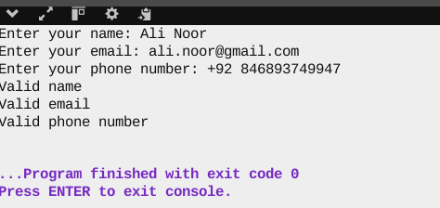

* Problem 5:

Source code:

#include <stdio.h>

int main()

{

int n,i,max,min;

printf("Enter the size of array: ");

scanf("%d",&n);

int a[n];

printf("Enter %d array elements:\n ",n);

for (i=0;i<n;i++)

{

scanf("%d",&a[i]);

}

for (i=0;i<n;i++)

{

max=a[0];

min=a[0];

if (a[i]>max)

max=a[i];

if(a[i]<min)

min=a[i];

}

printf("Maximun number is: %d\n",max);

printf("Minimum number is: %d",min);

}

Output:

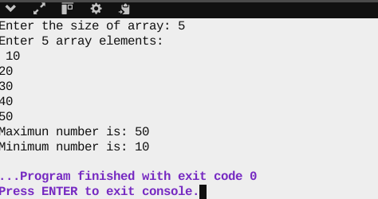

* Problem 6:

Source code:

#include <stdio.h>

int main()

{

int t[7];

int i,max=t[0],min=t[0];

float sum=0;

printf("Enter 7 temperature values:\n ");

for (i=0;i<7;i++)

{

scanf("%d",&t[i]);

}

for (i=0;i<7;i++)

{

if (t[i]>40 || t[i]<0)

printf("Extreme temperature at day %d\n",i+1);

}

for (i=0;i<7; i++)

{

sum=sum+t[i];

}

printf("Average temperature is: %f",sum/7);

}

Output:

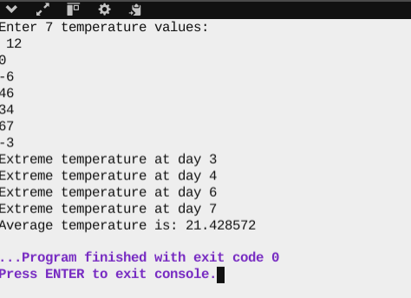

* Problem 7:

Source code:

#include <stdio.h>

int main()

{

int n,sum=0,i,j=0;

printf("Enter the size of array: ");

scanf("%d",&n);

int a[n];

printf("Enter %d array elements:\n ",n);

for (i=0;i<n;i++)

{

scanf("%d",&a[i]);

}

for (i=1;i<n;i++)

{

if (a[j]==a[i])

printf("%d occurs more than once",a[i]);

j++;

}

}

Output:

